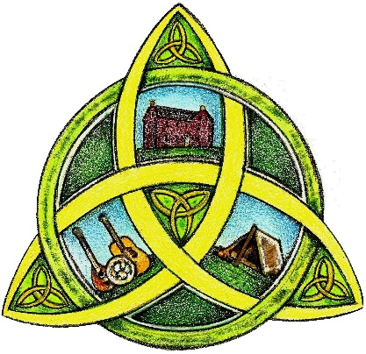
VENDOR REGISTRATION FORM
2026 Celtic Heritage Festival
Saturday & Sunday, June 20 & 21, 2026
Event Hours: 10 am to 8 pm on Saturday
10 am to 6 pm on Sunday

REGISTRANT INFORMATION

Name of Entity:

Contact Person - First Name: Last Name:

Mailing Address:

Email Address:

Phone:

Website (if applicable):

What information or service do you provide to the community?

REGISTRATION FEE: $50.00, includes both Saturday & Sunday

Booth Spaces will be assigned; space will accommodate up to a 10x12 canopy. An additional 10x10 space is available for $10. Vendors will set up in an open field and are responsible for supplying their own canopies, tables, and chairs, etc.

Inverter style generators are allowed, or you may request a booth space with electric hook up; these will be limited & available on a first come, first served basis, and may require vendor to supply adequate length electric extension cord.

Tents/canopies need to be secured with stakes or weights in case of wind.

Participants will receive two entry passes in the mail prior to the event. Please have these to show at the main gate & then display in your car widow during the event.
Anyone driving separately to assist at your booth will pay a fee of $5 per vehicle. Requests for more parking passes must be made two weeks prior to the event. Vendors and their helpers are encouraged to carpool.

Set-up can begin on Friday, June 19, after 12 pm, or from 7 am to 9:30 am on June 20th. You may unload in the event area, then park your vehicle in the designated vendor parking area. Vendors are not allowed to leave the event early unless the Johnston Farm & Indian Agency closes the event (for inclement weather, etc.) Vehicles will not be allowed onto festival grounds until after the festival closes for safety reasons.

Please RSVP as soon as possible to reserve a spot. Please sign and return your completed application and payment no later than May 22, 2026.

The Johnston Farm & Indian Agency and the Johnston Farm Friends Council will not be held responsible for any damage or losses suffered by participants in the event.

Signature: | Date:

MAIL COMPLETED FORM TO: Make Checks Payable to:

Johnston Farm & Indian Agency Johnston Farm Friends Council
Attn: Diana Leach
9845 N. Hardin Rd.
Piqua, OH 45356

For additional information, contact Diana Leach at diana.leach@johnstonfarmohio.com
Phone: (937) 773-2522

